Project Title

Ensuring process efficiency in purchase order (PO) approval days and
Spent Analysis

Date: 18th October 2025
Author: Michael Obeng Asiedu (Procurement Supervisor)

Executive Summary
The analysis reviewed 203 suppliers with material groups which include Administration, asset, chemicals, consumables, electrical, IT equipment, laboratory, maintenance service, mechanical and miscellaneous. With a yearly spent which is trended and analysis shows concentration of orders in specific material groups and specific buyer’s spent. With recommendations, where firms see the need to adapt strategies to minimise cost in specific category and ensure value addition by ensuring process efficiency by ensuring timely approval of purchase orders (PO), by creating an operational dashboard to monitor specific key indicators.
Problem Statement
The objective of this project is to analyze spent data to understand where firm needs to focus to ensure cost-efficiency optimization and process performance in terms of timely PO approval to ensure goods & services are delivered on time to prevent production disruption. Hence the analysis seeks to answer the following business challenges/questions;
- Which category or material group is the highest spent within a financial year?
- Which approver’s have the highest PO approval aged days to ensure the need to streamline?

Data Understanding
Dataset Description;
- Number of records: 203
- Number of columns: 21
Key Fields: PO numbers, PO value (Price X PO quantity), PO approval days, Material Group, PO creator, PO approver
Methodology
- Data cleaning; Check 64 duplicates, removed 1212 unique values and empty cells, spaces and etc
- Slight feature engineering: Inserted a new column-PO approval ageing.
- Exploratory Analysis: Pivot tables to summarize spent per category or material group, and PO aged days per PO approvers
- Analysis Techniques: formula segmentation thus M2 (PO approved date)-K2 (PO created date)

Visualization: A dashboard with bar charts a donut chat and KPI cards as shown below.

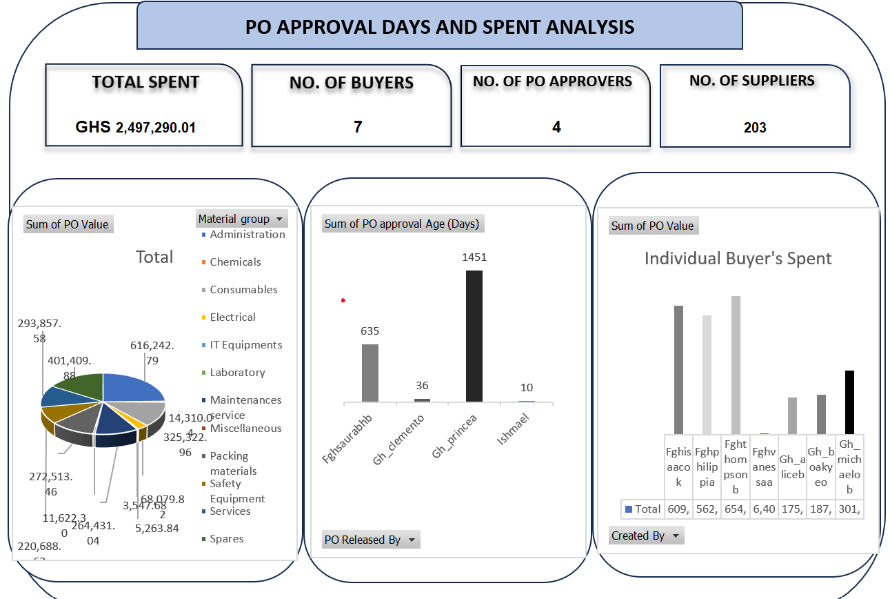

Discussion & Interpretation:
- Highest spent is IT equipment which amounts to GHS 616,242.79
- GH_Princea cumulatively with the highest days of 1451 days in PO approvals
Recommendations
- Ensure strategic sourcing to identify substitute suppliers with competitive rates to supply IT equipment or better use as a benchmark for discount from existing supplier.
- Ensure Approver can have alternative platform such as phone with the installed enterprise via outlook to approve POs.

